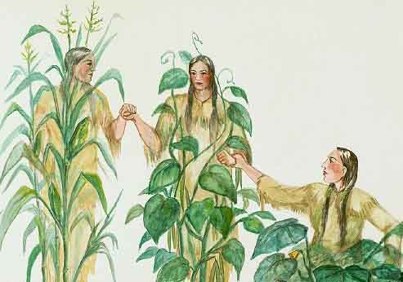

The Three Sisters – Corn, Bean and Squash
Corn acts as a support for climbing bean vines, the beans fix nitrogen in the soil for the high feeding requirements of corn and squash, and the squash provides mulch and root protection for the corn and beans! After cooperating beautifully in the garden, corn and beans form a complete protein when eaten together! How’s that for a mutually beneficial relationship?

Source: https://countryandvictoriantimes.com/2013/02/03/the-three-sisters-corn-beans-and-squash/

